Ai assisted coding Assignment-16.4
Name:E.Srivarsha
Batch-44
HTNO:2303a52343
Task 1: Schema Design
Prompt: Generate SQL CREATE TABLE statements for an online course platform with the following entities: Instructors, Courses, Students, and Enrollments. Include primary keys, foreign key relationships, and appropriate data types. Ensure the schema follows normalization principles (up to 3NF).
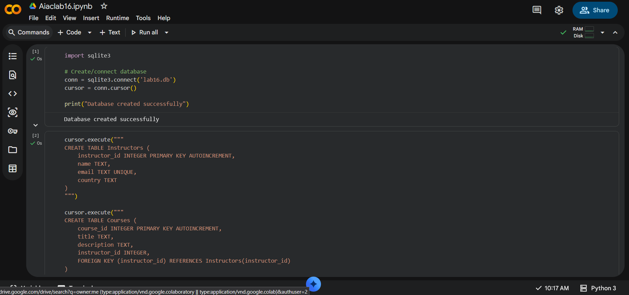
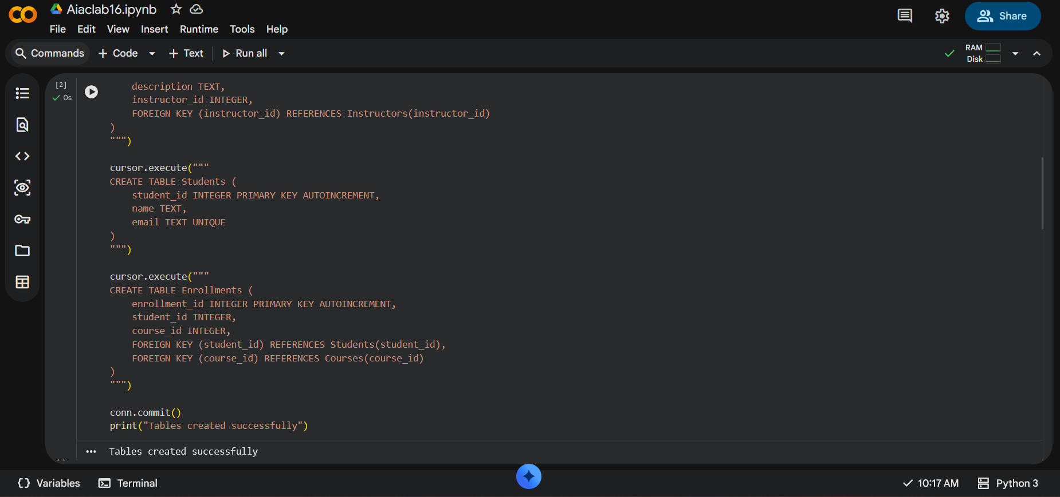
Observations:
Tables were created with proper primary and foreign keys.
Relationships between entities were correctly established.
The schema follows normalization and avoids redundancy
Task 2: Data Insertion
Prompt:
Generate SQL INSERT statements to populate the Instructors, Courses, Students, and Enrollments tables with sample data. Include at least 3 instructors, 4 courses, and 3 students. Ensure foreign key relationships are maintained correctly.
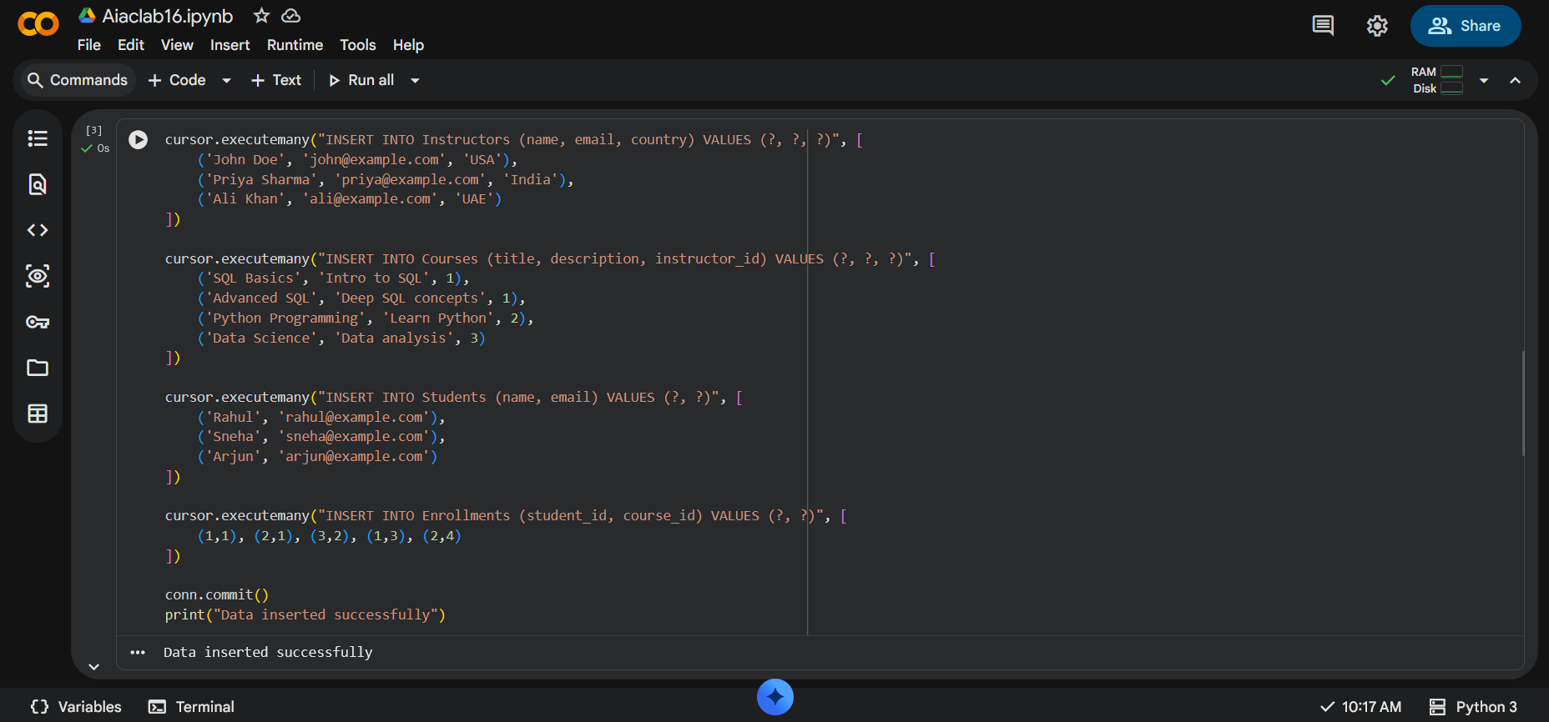
Observations:
- Sample data was inserted successfully without errors.
- All constraints (like UNIQUE and foreign keys) were satisfied.
- Data was verified using SELECT queries.

Task 3: CRUD Operations
Prompt:
Generate SQL queries to perform CRUD operations on the database. Include:
1. Retrieve all courses
2. Update a student’s email
3. Delete a course. Also include SELECT queries to verify each operation.
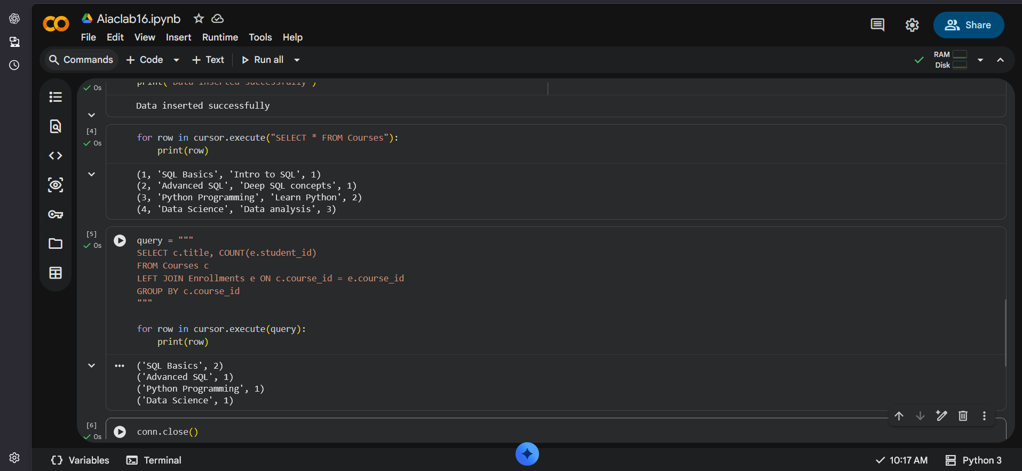
Observations:
- Data retrieval, update, and deletion worked correctly.
- Changes were reflected accurately in the database.
- No unintended data loss occurred.

Task 4: Aggregate Queries
Prompt:
Generate SQL queries using aggregate functions to:
1. Count the number of students enrolled in each course
2. Display courses with more than a specified number of enrollments
Use GROUP BY and HAVING clauses appropriately.

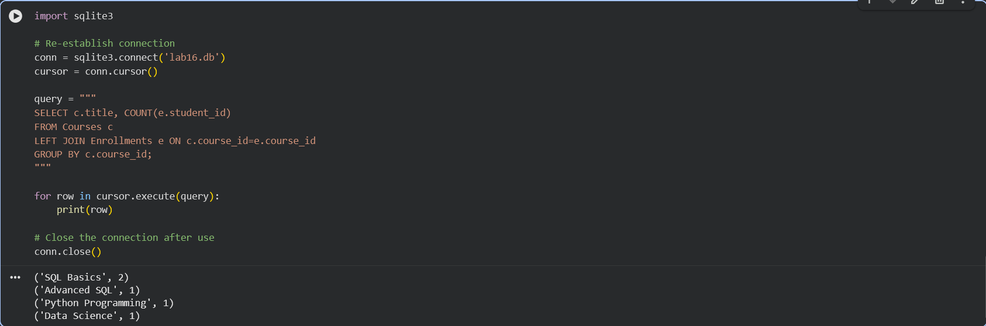
Observations:
- Aggregate functions like COUNT worked correctly.
- GROUP BY and HAVING produced accurate results.
- Queries provided useful summary insights.

Task 5: Query Optimization
Prompt:
Analyze and optimize an SQL query that retrieves courses taught by instructors from a specific country. Refactor the query using efficient JOINs and suggest indexing strategies to improve performance while ensuring the results remain unchanged.
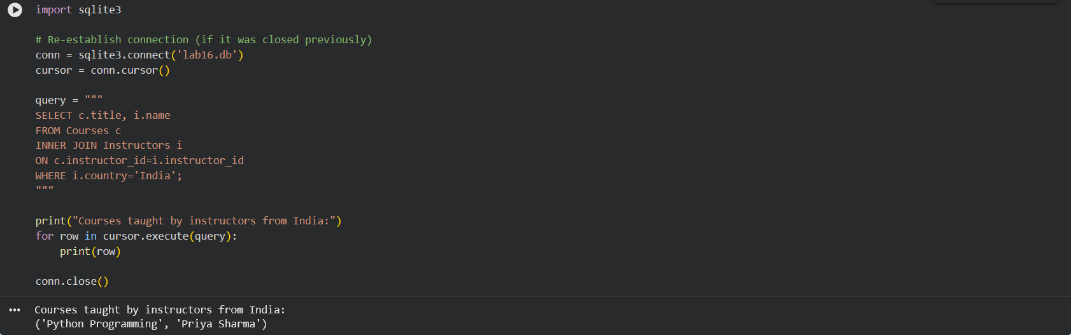
Observations:
- Query was improved using JOIN instead of implicit syntax.
- Performance can be enhanced using indexing.
- Optimized query produced the same correct results.

